Quickstart: Compose and WordPress
Estimated reading time: 3 minutes
You can use Docker Compose to easily run WordPress in an isolated environment built with Docker containers. This quick-start guide demonstrates how to use Compose to set up and run WordPress. Before starting, make sure you have Compose installed.

Define the project
- Create an empty project directory.
You can name the directory something easy for you to remember. This directory is the context for your application image. The directory should only contain resources to build that image.
This project directory contains a docker-compose.yml file which is complete in itself for a good starter wordpress project.
Tip: You can use either a .yml or .yaml extension for this file. They both work.
- Change into your project directory.
For example, if you named your directory my_wordpress:
- cd my_wordpress/
- Create a docker-compose.yml file that starts your WordPress blog and a separate MySQL instance with volume mounts for data persistence:
version: "3.9"

services:
db:
image: mysql:5.7
volumes:
- db_data:/var/lib/mysql
restart: always
environment:
MYSQL_ROOT_PASSWORD: somewordpress
MYSQL_DATABASE: wordpress
MYSQL_USER: wordpress
MYSQL_PASSWORD: wordpress

wordpress:
depends_on:
- db
image: wordpress:latest
volumes:
- wordpress_data:/var/www/html
ports:
- "8000:80"
restart: always
environment:
WORDPRESS_DB_HOST: db
WORDPRESS_DB_USER: wordpress
WORDPRESS_DB_PASSWORD: wordpress
WORDPRESS_DB_NAME: wordpress
volumes:
db_data: {}
wordpress_data: {}
Notes:
- The docker volumes db_data and wordpress_data persists updates made by WordPress to the database, as well as the installed themes and plugins. Learn more about docker volumes
- WordPress Multisite works only on ports 80 and 443.

Build the project
Now, run docker-compose up -d from your project directory.
This runs docker-compose up in detached mode, pulls the needed Docker images, and starts the wordpress and database containers, as shown in the example below.
docker-compose up -d
Note: WordPress Multisite works only on ports 80 and/or 443. If you get an error message about binding 0.0.0.0 to port 80 or 443 (depending on which one you specified), it is likely that the port you configured for WordPress is already in use by another service.

Bring up WordPress in a web browser
At this point, WordPress should be running on port 8000 of your Docker Host, and you can complete the “famous five-minute installation” as a WordPress administrator.
Note: The WordPress site is not immediately available on port 8000 because the containers are still being initialized and may take a couple of minutes before the first load.
If you are using Docker Desktop for Mac or Docker Desktop for Windows, you can use http://localhost as the IP address, and open http://localhost:8000 in a web browser.
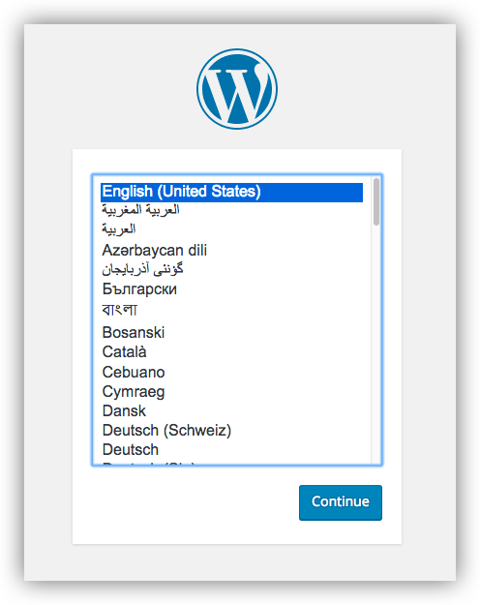
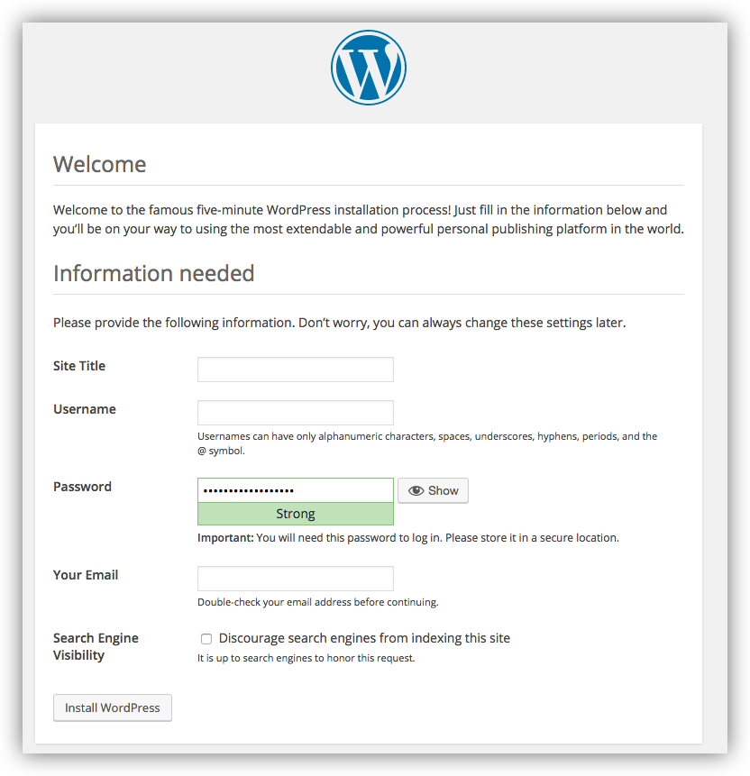

Shutdown and cleanup
The command docker-compose down removes the containers and default network, but preserves your WordPress database.
The command docker-compose down --volumes removes the containers, default network, and the WordPress database.
https://docs.docker.com/samples/wordpress/

